**COE 233, Term 231, HW2**

Q1) , Q2), Q3) Solutions are in separate files.

Q4) You are required to design a combinational circuit that computes the equation

$Z=3-|X|$ Where $X\left[3:0\right]$ is 4-bit **signed** binary number in 2’s complement representation.

1. Fill in the following table with the values of Z for each input value of X.

|  |  |
| --- | --- |
| X3X2X1X0 | Z3Z2Z1Z0 |
| 0000 | 0011 |
| 0001 | 0010 |
| 0010 | 0001 |
| 0011 | 0000 |
| 0100 | 1111 |
| 0101 | 1110 |
| 0110 | 1101 |
| 0111 | 1100 |
| 1000 | 1011 |
| 1001 | 1100 |
| 1010 | 1101 |
| 1011 | 1110 |
| 1100 | 1111 |
| 1101 | 0000 |
| 1110 | 0001 |
| 1111 | 0010 |

b) By:

1- storing the Zs (the red bits) in a room of size 16x4

2- connect the Xs to the address lines of the memory

3- The output is delivered from the data pins of the ROM

You can illustrate your solution:

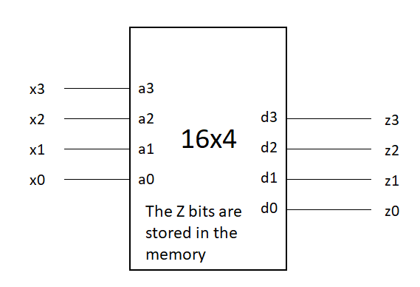

Q5)

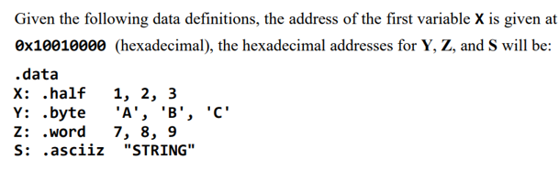

**Address of Y = 0x10010006**

**Address of Z = 0x1001000c**

**Address of S = 0x10010018**

**Address of number 3 = 0x10010004**

**Address of number 9 = 0x10010014**

**Address of the null character of string S = 0x1001001e**